**ATAR HUMAN BIOLOGY – UNIT 1**

**TASK 4 – CIRCULATORY AND RESPIRATORY SYSTEMS TEST**

**NAME: _________________________________ WEIGHTING: %**

**DUE DATE: _________________________________ MARK: ______ /56 = ______ %**

***MULTIPLE CHOICE SECTION***

1. D
2. C
3. C
4. B
5. A
6. C
7. D
8. D
9. C
10. A
11. A
12. B

***SHORT ANSWER SECTION [TOTAL = 36 MARKS]***

This section has **nine** questions. Answer all questions in the spaces provided.

1. Below is a cross-sectional diagram of a human heart

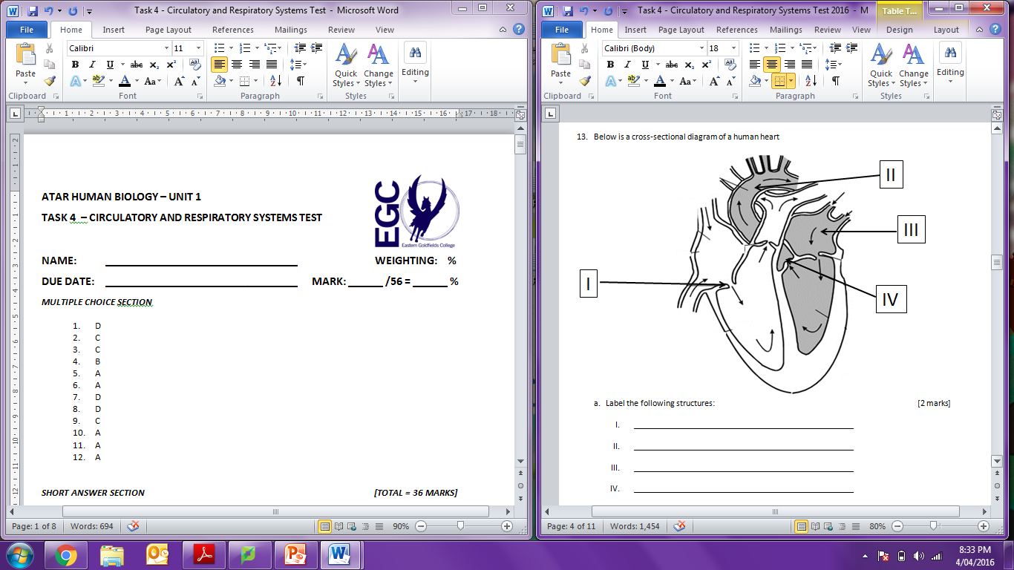

Label the following structures: [2 marks]

* 1. Atrioventricular valve (tricuspid valve)
  2. Aorta
  3. Left atria
  4. Semilunar valve

1. Compare the structure and function of vessel **II** with structure and function of the vessels entering part **V**. [2 marks]

* II is an artery/carries blood away from heart to the body   
  thick muscular wall/narrow lumen/no valves (1)
* V is a vein/carries blood to heart  
  thin walls/wide lumen/valves to stop back flow of blood (1)

c. Explain what would happen to structures I and IV during diastole and articular systole. [1 mark]

- Diastole: I is open/IV is closed  
- Articular Systole: I is open/IV is closed

1. Some individuals have additional fat deposits on the inside of their blood vessels. Explain the effect this would have on the individual’s blood pressure and why this would occur? [2 marks]

Lumen/diameter decreases, same amount of blood forced through (1)  
leads to increased pressure (1)

1. Sometimes babies can be born with a hole connecting the two atria of the heart. Explain why a ‘hole in the heart’ is a serious problem. [2 marks]

Allows the mixing of oxygenated and deoxygenated bloods (1)

Decreased oxygen to babies system/cannot fully respire (1)

2. Both the lymphatic and circulatory system carry fluids around the human body. Briefly describe two (2) features of the lymphatic system that differ to the circulatory. [2 marks]

* More permeable (1)
* One way flow (1)
* Relies on muscles and valves to move fluid (1)
  + *Any feasible response* (1)

1. 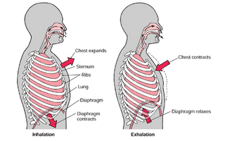In the space below, draw a diagram with annotations explaining what happens to the chest cavity during inspiration. [4 marks]

2. Diaphragm contracts (moves downwards) – Increases chest cavity (1)

3. Increased chest cavity 🡪Increased cavity volume/decreased pressure. Means air rushes into lungs as pressure outside body is higher (1)

1. Intercostal muscles contract, pulling ribs outwards – Increases chest cavity (1)

Drawing (1)

1. Below is a table that shows the proportion of oxygen and carbon dioxide and how it is transported in blood

|  |  |
| --- | --- |
| **OXYGEN** | **CARBON DIOXIDE** |
| 3% Dissolved in plasma | 8% dissolved in plasma |
| **I.** | **II.** |
|  | 70% as Bicarbonate ions |

* 1. Fill in the missing forms of transport from the above table. [2 marks]  
     1. 97% as oxyhaemoglobin
     2. 22% as Carbaminohaemoglobin
  2. Bicarbonate ions are the result of a chemical reaction within the body. Explain how these ions are formed and used to transport carbon dioxide. [2 marks]
* Carbon dioxide + water 🡪 carbonic acid (1)
* Carbonic acid dissociates (breaks down) into hydrogen ions and bicarbonate ions (1)
  1. Fill in the table below. [5 marks]

$\frac{1}{2}$ mark per correct box

|  |  |  |  |  |
| --- | --- | --- | --- | --- |
|  | **FORMED ELEMENTS** | | | **LIQUID PART** |
| **Red Blood Cell** | **White Blood Cell** | **Platelet** | **Plasma** |
| **SCIENTIFIC NAME** | Erythrocyte | Leukocyte | Thrombocyte |  |
| **ROLE IN THE BODY** | Carry O2/CO2 around the body | Protection of the body | Blood clotting | Medium that carries nutrients/wastes around body |
| **LIFESPAN** | 120 days | 1 day | 7 days |  |

* 1. Anaemia is a condition where the body is low in Iron. Anaemiacs (people with anaemia) often complain of being tired and become exhausted easily despite having a good night’s sleep.  
     Explain what is occurring in an anaemiacs body. [4 marks]
* Iron needed to make haemoglobin (1)
* Haemoglobin carries oxygen (1)
* Lack of iron means carries less/low levels of oxygen (1)
* Only enough oxygen to tissues to make energy /no extra for doing anything other than resting, thus person is tired (1)
  1. Describe the main events that occur during blood clotting. [3 marks]
* Muscles in walls of damaged arteries constrict, reducing blood flow ($\frac{1}{2}$)
* Platelets stick to walls and each other($\frac{1}{2})$
* Clotting factors released($\frac{1}{2})$
* Fibrin holds platelets in place. This forms a ‘plug’/fibrin forms mesh over platelets ( $\frac{1}{2}$)
* Threads from plug contract, releasing fluid ‘serum’($\frac{1}{2})$
* This dries and forms a scab($\frac{1}{2})$

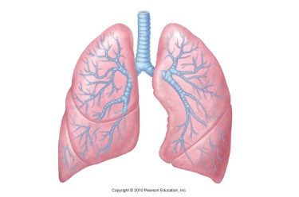

1. The lung is a very good example of a surface which enables exchange of materials to occur efficiently in the human body.
2. Name any two (2) features of the lungs and describe how they are suited to their role in gas exchange [2 marks]  
   Any 2 of the following:
   1. SA to Vol. ratio: increased area for diffusion of gases (1)
   2. One cell thick: gas molecules do not have far to travel (1)
   3. Blood supply: well supplied blood vessels, maintains O2 and CO2 concentrations (1)
   4. Moist/deep: prevent excessive evaporation as allows gases to diffuse when dissolved in fluid (1)
   5. Lung volume: altered, allows difference in concentration of O2 and CO2 in air and blood (1)

*Answer must have feature AND matching description to get the mark.*

1. The trachea and bronchi have C-shaped cartilage surrounding them. What is the purpose of the cartilage? [1 mark]

Give the trachea shape and hold it up/open (1)

1. A person is involved in a crash accident, out on the Eyre Highway. Because he is losing blood fast the paramedics decide to he needs to be given blood to replace what he has lost. Unfortunately, the person is unable to talk and cannot tell paramedics what blood group he has. What blood could he be given and describe why. [2 marks]

Blood group O

Has no antigens on the surface (1)

so body will not make any antibodies against it (1)

***EXTENDED ANSWER SECTION [TOTAL = 10 MARKS]***

1. Haemolytic disease in the second born child occurs when the red blood cells of the child are destroyed by antibodies produced by the mother. This problem comes about when the Rhesus positive red blood cells of the child cross the placenta into the mother’s circulatory system that contains Rhesus negative blood type.
2. Using your knowledge of blood groups, describe:

* How the mother would develop antibodies against her own child’s blood
* Mother is Rh-, does not contain antigen on RBC (1)
* Children are Rh+, RBC contain antigens (1)
* In response to the Rh+ antigens from second child, mother’s WBC produce anti-bodies (1)
* What effect the production of rhesus anti bodies would have on the health of the first born child.
* First born child likely to be healthy (1)
* Mother not yet sensitised to Rh+ and slow to produce anti-bodies (1)
* What effect the production of antibodies would have on the second child.
* Blood from first child and mother mix, mother is sensitised/recognises to Rh+ blood/If second child is Rh+, mother already has antibodies present in her body from first pregnancy (1)
* Antibodies attach to antigens on babies red blood cells while in utero (1)
* Antibodies attack Rh+ cells/ Large number of antibodies ‘flag’ babies red blood cells for ‘destruction’ (lysis) and child will be harmed/die (1)

1. Explain what measures the mother could take to avoid haemolytic disease in the second born.

[2 marks]

Mother can get testing when she knows she is pregnant to test blood type of baby (1)

Be injected with RhIg before being sensitised/recognises Rh+ blood or get transfusions during pregnancy if sensitised (1)

***END OF TEST***